# Help Function - Updated Python Exercise

Below is the image provided along with the recreated question, terminal output, and answer:

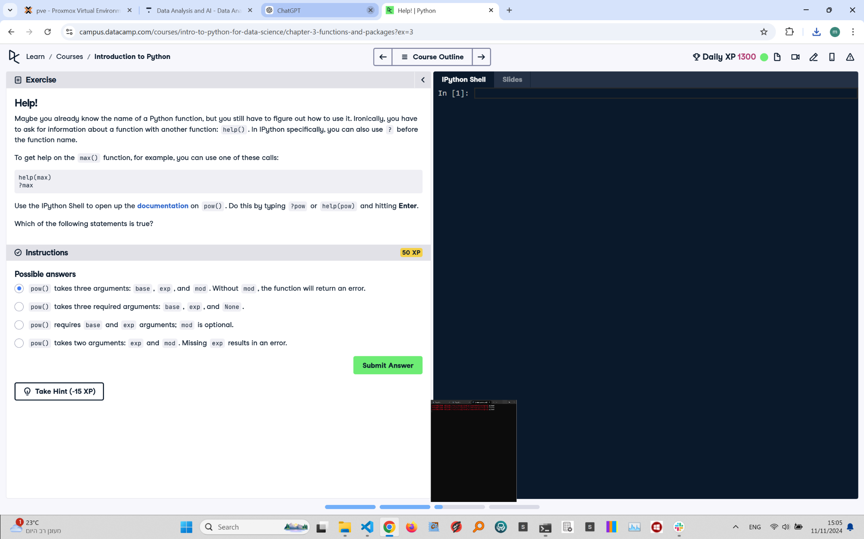

## Updated Question and Terminal

Help!  
Maybe you already know the name of a Python function, but you still have to figure out how to use it. Ironically, you have to ask for information about a function without knowing how to use it.

To get help on the max() function, for example, you can use one of these calls:  
  
help(max)  
?max

Instructions:  
Use the IPython Shell to open up the documentation on pow(). Do this by typing ?pow or help(pow) and hitting Enter.  
Which of the following statements is true?

## Answer

The correct statement is:  
- pow() requires base and exp arguments; mod is optional.

## Explanation of the Updated Answer

The pow() function in Python requires at least two arguments: base and exp. The third argument, mod, is optional. If provided, pow() computes (base ** exp) % mod. Otherwise, it calculates base ** exp. Using help(pow) in IPython verifies this information.